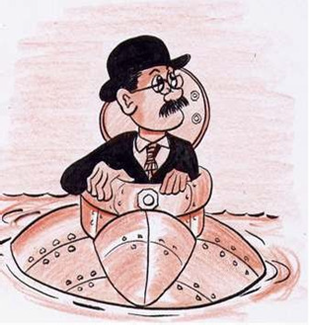
Illustration of John Phillip Holland ©John Joyce, 2006
A Personal Letter to John Phillip Holland

What changes happened with transport and shipping in John Phillip Holland’s lifetime.
Think about the transport people were using as well as the ships and submarines that were used in the late 19th century and early 20th century.
Submarines have evolved over time from simple submersibles to nuclear-powered super weapons. They have also been developed for marine research and for salvaging in the deepest parts of the ocean.

WRITE A LETTER:

Write a personal letter to John Phillip Holland and tell him how submarines and submersibles are used today. This includes using them for marine research, scientific discoveries, monitoring of oil and gas rigs at sea, salvage of shipwrecks, and even tourism.

When writing a letter remember:
- Your address should be displayed at the top (either on the left of right side of the page)
- The address of the person you are writing to e.g. John Phillip Holland is to be displayed on the left beneath your address. You can send your letter to:
C/o The Explorers Education Programme Team
The Camden Education Trust
Galway Education Centre
Galway
- The date should be displayed just below the address on the left
- Your greeting should be displayed on the left side of the page beneath the date e.g. Dear John,
- The main body of your letter is to be written under the greeting.
- At the end of your letter sign off the letter with: Kindest Regards, Yours Faithfully, or Yours sincerely and sign your name.
- After your signature, you should print your name.

You may like to decorate your letter with pictures of submarines and submersibles that are used in this century.

__________________________________________
__________________________________________
__________________________________________

__________________________________________
__________________________________________
__________________________________________
__________________________________________

__________________________________________

________________________________________________________
____________________________________________________________________________
__________________________________________________________________
__________________________________________________________________
__________________________________________________________________
__________________________________________________________________
__________________________________________________________________
__________________________________________________________________
__________________________________________________________________
__________________________________________________________________
__________________________________________________________________
__________________________________________________________________
__________________________________________________________________
__________________________________________________________________
__________________________________________________________________

_________________________________
_________________________________

ships that were used in the late 1800’s to the changes during the 1st World War.
___________________________________________________________________
______________________________________________________________________________________________________________________________________
_____________________________________________________________________________________________________________________________________
___________________________________________________________________
______________________________________________________________________________________________________________________________________
___________________________________________________________________ happened with technology and transport in John Phillip Holland’s lifetime. Think about the
ships that were used in the late 1800’s to the changes during the 1st World War.
___________________________________________________________________
______________________________________________________________________________________________________________________________________
_____________________________________________________________________________________________________________________________________
___________________________________________________________________
______________________________________________________________________________________________________________________________________
___________________________________________________________________
My Personal Letter to John Phillip Holland

